Plate bending with a circular hole - Validation in Kratos with IGA element

Objective:
Validate the Plate bending with a circular hole with Kratos I GA Shell3pElement for linear analysis.
Validation is performed against Michael Breitenberger's Dissertation – Examples – 7.3

- Model Description:
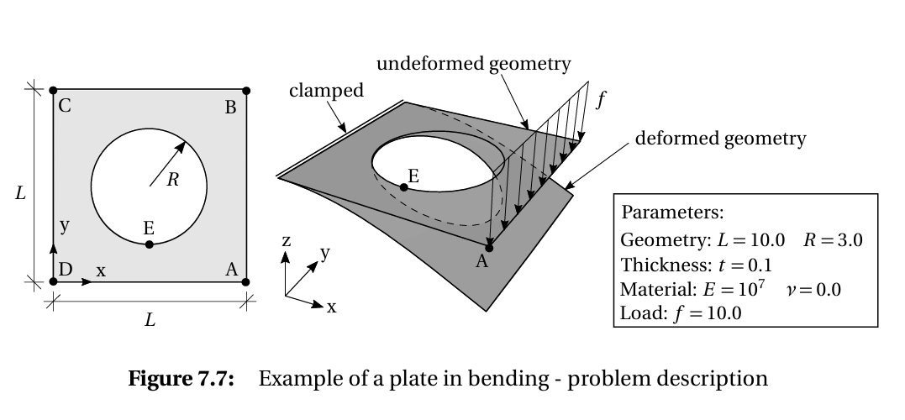
Fig.1: Plate with a circular hole in Bending - Taken from Michael Breitenberger's Dissertation

- Results:

The Z displacement convergence value of -6.4313 units is achieved.
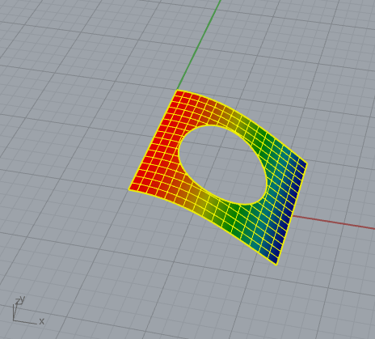
Fig.2: Deflection Diagram for CP of 15*15

In the convergence plot, the number of control points in the x and y directions is kept the same. The convergence plots shows number of control points added additionally with a curve degree of 2 in both directions.
Control Points Refinement | Z-Displacement
2 | -6.2753
5 | -6.4006
10 | -6.431
15 | -6.431

Table 1: Displacement Convergence Values
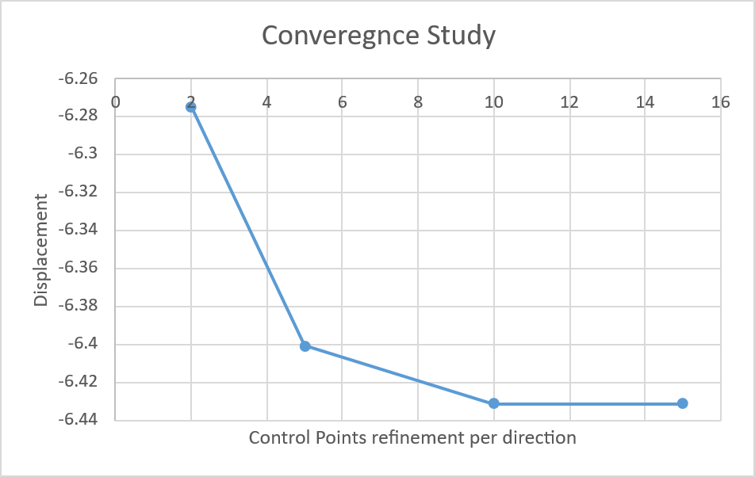

Figure 3: Convergence Plot

